**Summary of selection process**

My first step was to check out the excel file containing the player salaries which was provided on the Blackboard portal and sort the players according to their positions. I began with the Starting Pitchers and checked out fangraphs.com to get the WAR ratings of the players. I sorted the players by selecting ‘SP’ as the filter in the ‘Position’ column in the salary excel and I started to search the salaries of the players who featured on the fangraphs.com at ‘Leaders -> Pitching -> 2021 -> Starters’ table. I started with Corbin Burnes and put him straight on the team sheet. I kept on doing the same for all the positions.

For all the starting pitchers, I wanted players who have high WAR and less than 180 IPs so that my normalized WAR (against 180 IPs) is greater than the original fangraphs.com WAR rating. I applied the same strategy for relief pitchers and normalized their WAR against 60 IPs. For all the offence players, I wanted to include the players who had a high WAR rating and less than 600 PAs to have a high normalized WAR. Now, as suggested in the assignment, we can select retired players, therefore I went ahead with selecting Buster Posey.

As instructed, I have selected the last team for which the player played for as his team. Coming to the positions, for the position ‘IF’, I selected the ‘INF’ filter from the salaries excel in the ‘Positions’ column and selected the players from the filtered list. I applied the same method for the positions ‘OF1’ and ‘OF2’. Players in all the rest of the positions are aligned to their positions as provided on fangraphs.com. I kept all the various constraints which were given in the assignment like number of players from same team, salary ranges, salary cap etc in check and my final line up cost came up to **$120,658,914**. The final average normalized WAR of my starting lineup came up to 4.697 which can be rounded off to **4.7**.

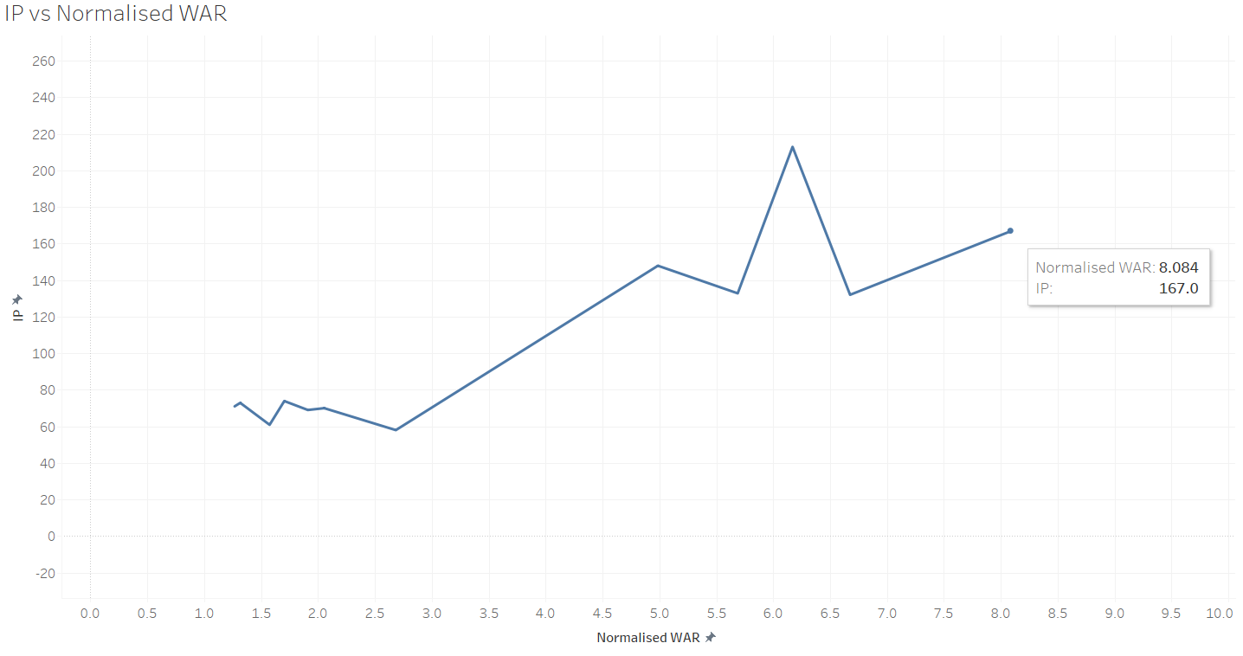

Figure 1: Graph showing IP vs Normalized WAR

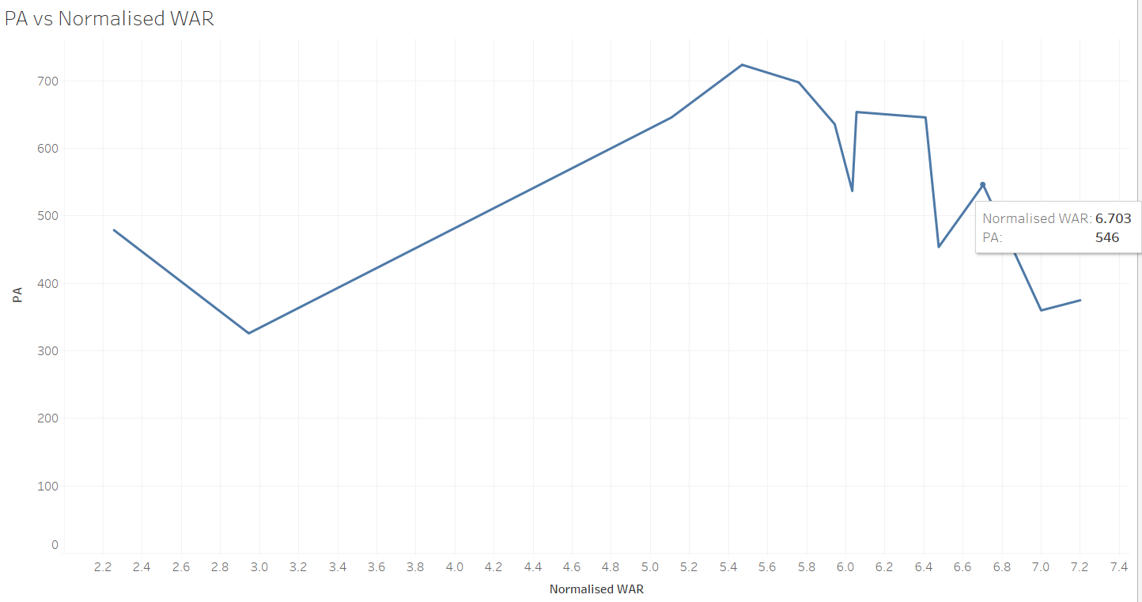

Figure 2: Graph showing PA vs Normalized WAR